**Lit Review Notes**

**Overall Structure**

**Intro**

“A good portfolio is more than a long list of good stocks and bonds. It is a balanced whole, providing the investor with protections and opportunities with respect to a wide range of contingencies” - (Harry Markowitz, 1959)

**These first sections on investment theory may be going into too much depth? Perhaps this could be condensed?**

**What is a portfolio/investment**

An investment portfolio can be defined as a group of financial assets that include stocks and bonds but can also range from commodities such as real estate, precious metals like gold and silver and also cash.  The investor who owns the portfolio typically holds it to earn a profit however almost every investment incurs some form of risk which means that the investor cannot associate an investment with a single value of payoff since there are multiple outcomes that the investment could arrive at (Edwin J page 44).This incurred risk brought on by investing can be minimised by creating a portfolio of mixed asset classes; otherwise known as diversification. (Corporate Finance Institute, 2019). For example a portfolio that contains assets entirely related to 1 industry is less diverse than a portfolio that contains assets belonging to a wide variety of sectors. This is due to the fact that firms that belong to the same industry tend to perform poorly at the same time compared to companies from different sectors (Markowitz, 1952). A major challenge when creating financial portfolios is deciding how to allocate ones wealth among the individual assets in order to reduce the risk for a desired expected return which is why over the last 60 years, different investment portfolio theories have been crafted to try and provide investors with methods of estimating risk and return for a given asset(s) (Omisore, Yusuf, Christopher, 2012).

**Modern Portfolio Theory**

Harry Markowitz provided a solution to the diversification problem with modern portfolio theory which defines a method for calculating the expected return for a group of assets as well as its variance by looking at the assets historical data (Edwin J and Martin j, 1995). Furthermore, Markowitz outlined the idea that it is not enough to just calculate the risks of the individual assets that make up the portfolio, but it is also necessary to analyse how the correlations between these assets can influence the variance of the portfolio as a whole (Edwin, 1995). Therefore, using MPT to diversify one's portfolio allows for the generation of a set of optimized portfolios that forms an efficient frontier. (See Figure 1). These portfolios are optimised because every portfolio that lies on the efficient frontier is providing the greatest level of return for a given level of risk or is providing the lowest level of risk for a given expected return (Fabozzi, 2002). All other possible portfolios are labelled by MPT as inferior because they either incur unnecessary risk or provide a suboptimal return.

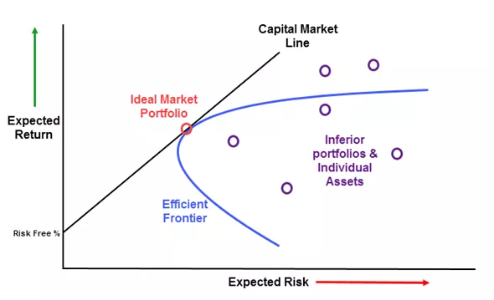

**Figure 1 - Harry Markowitz’s graph of the efficient frontier (Investopedia, 2019)**

Although figure 1 displays all of the most efficient portfolios which lie on the efficient frontier, an investor will still have to choose between portfolios that have different levels of risk and returns (Dowd, 2000). The sharpe ratio developed by William F. Sharpe can be used to measure the relationship between a portfolio's expected risk and return. The greater the sharpe ratio for a portfolio, the more optimised the risk-adjusted return which figure 1 highlights as the ideal market portfolio (Investopedia, 2019).

​

**Modern Portfolio Theory Disadvantages**

Despite modern portfolio theory prominence as a means for asset selection and portfolio management, it can be argued that its effectiveness is limited because the way that it measures risk is does not account for investment market realities. Markowitz himself even recognized the limitations of his theory; stating that MPT can lead to suboptimal predictions under certain scenarios even went on to suggest that a model based on semi-variance would be preferable (Sharpe, 1964). For example, according to modern portfolio theory, the 2008 financial crash was statistically a 1 in 10,000-year event which suggests that there are factors that MPT is not able to take into consideration. Rice argues that one of the reasons behind this oversight is that MPT only calculates risk based on previous performance however in today’s economy is greatly influenced by policy makers whose decisions are not based on the historical patterns of asset prices but instead are often motivated by politics and other means (Rice 2017). This behaviour can be highlighted by the United States central banking agency known as the Federal Reserve which has large influence over the financial market via its control over interest rates and monetary policy (Board of Governors of the Federal Reserve System, 2005).

**Alternatives**

**Postmodern Portfolio Theory**

Following the development of financial and investment theory since Markowitz proposed theory as well as the increase in computing power, many of the limitations that resulted from MPT have been overcome leading way for new algorithms aiming to solve the portfolio optimisation problem. MPT holds a symmetric view of measuring risk in the sense that all uncertainty with regards to a portfolio is treated the same weather that uncertainty be on the upside or the downside (Rom and Ferguson, 1994) . An iteration of MPT called post modern portfolio theory argues that risk is not symmetrical and but is severely skewed due to the fact that investors tend to prioritise avoiding a loss rather than seeking gain. **(Why Investors Make the Wrong Choices, Fortune Magazine, 1987**). Research done on investor behaviour shows that investors are aiming for a minimum desired return and any results below this are seen as a loss while results above the expected level can be disregarded. (Tsai, Wang,2012). This view of investor behaviour is contradictory to MPT’s which assumes investors are rational beings simply seeking investments/portfolios with the lowest level of risk for a given return or vice-versa (Omisore, Yusuf, Christopher, 2012). PMPT favours the former view on investor behaviour and is used as the basis for producing a measurement of risk that is specific to the goals of the investor (Rom and Ferguson, 1994). Additionally, PMPT improves its ability to calculate the risk and reward relationship of a given asset by replacing the Sharpe ratio with the Sortino ratio which uses the downside deviation as a measure of risk instead of standard deviation (Rollinger and Hoffman, 2013).

**MPT Alternative using Machine Learning**

To Complete

**Finance Technologies and Tools**

**Python**

Information age technology has been playing an ever-expanding role in the financial industry with regards to trading and one of the technologies that has allowed this expansion is the Python programming language (Hilpisch, 2016). Over time Python has seen an increase in use for applications that perform calculations on large volumes of data which have typically been dominated by languages such as R and MATLAB. This is in part due to increasing list of libraries such as NumPy, SciPy and Pandas which provide reliable and well documented methods for data manipulation (Mkinney, 2010). Libraries dedicated to finance such as pyfolio and zipline also highlight Pythons suitability for solving finance related problems. Furthermore, Python is a more general purpose language compared to the usual data science programming languages as it can be used to develop software outside the sphere of data science including web development, database interaction and scripting (Nelli, 2015). This general purpose in Pythons design allows developers to write complex data science algorithms and combine them with a front end web application that allows users to easily interact with said algorithms.

Unlike languages such as C or Java which are compiled, Python is an interpreted language which means that its execution its execution of things like nested loops can be significantly slower than compiled languages. This drawback is especially costly in computations related to finance which rely heavily on nested loops however libraries have been developed to reduce the time it takes to execute certain blocks of code. Numba for example, translates Python functions to optimized machine code at runtime which can help numerical algorithms developed in Python run at speeds similar to C or FORTRAN (Numba, 20??).

**Matplotlib**

The matplotlib package is an open source 2D plotting tool for python that allows developers to generate a wide variety of graphs for data visualisation ranging from pie charts to candlestick graphs which are widely used throughout the finance sector for their ability to summarise important stock behaviour in a manner that is easy to visualise (Investopedia, 2019 ). As highlighted in figure 2, the candlestick graph can inform an investor of a stocks opening and closing price as well as the highest and lowest values that it reached over the course of a day, month, year etc… The colour of the candlestick is used to specify whether the closing price is above or below the opening price.

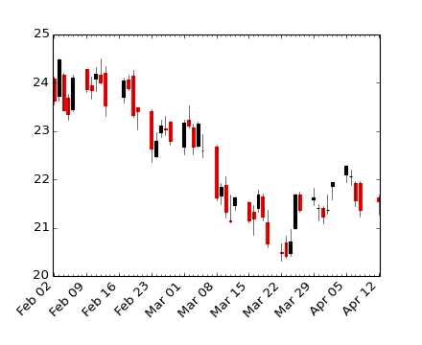

**Figure 2 - Generic candlestick graph (matplotlib)**

**Web Framework**

**Flask**

Flask is a micro framework based in Python which provides the basic functionality of a web framework. The term micro framework means that the core features are simple but plugins and extensions can be added to extend beyond the basic functionality (Aslam, Nabeel, 2015).

Unsure how much more I would need to discuss. Most of the material on it is very in depth and technical and not that relevant to the topic.

**Why the application is needed**

This section seems too off topic but i thought providing an underlying reason as to why a portfolio app could be useful and who it could be useful for would be interesting. Maybe this could be condensed?

**Savings/Retirement crisis**

“Most older Americans are not at all confident about the efficacy of their efforts to save for retirement, and in fact one-third of adults in their 50s have failed to develop any kind of retirement saving plan at all (Lusardi 1999, 2003; Yakoboski and Dickemper, 1997).”

Many studies have suggested that a large portion of the population are financially illiterate which could help explain why many households reach retirement with little to no savings to rely on (Lusardi and Mitchell 2007). A study conducted by the Jump$tart Coalition for Personal Financial Literacy found that U.S. high school students fared poorly on questions regarding credit management and personal finance questions.

This problem is exacerbated by an ageing population brought about by an increase in life expectancy along with a lower fertility rate due to people having on average fewer children[3]. Overall

**Government Response to savings crisis**

In response to this lack of financial planning from the population, the UK government has been implementing a number of schemes that attempt to incentivise long term investing. The Lifetime Individual Savings Account, for example, helps people save towards buying their first home or save for retirement by having the government pay 25% of what the account holder puts into the account. Furthermore, in 2012 the UK government mandated by law that all employers must enroll their employees into a pension scheme (GOV.UK, 2019).

People are not saving for retirement <https://www.nber.org/papers/w17078.pdf>

People not saving for retirement: <https://www.dartmouth.edu/~alusardi/Papers/Lusardi_pdf.pdf>

[3] Ageing population <https://www.ons.gov.uk/peoplepopulationandcommunity/birthsdeathsandmarriages/ageing/articles/livinglongerhowourpopulationischangingandwhyitmatters/2018-08-13>

Aging population<https://www.nber.org/papers/w16705.pdf>

**Conclusions**

**Source 4 - Risk tolerance in financial decision making**

My point -> Assumes that investors are rational and will select a portfolio with less risk. This paper backs this up by going into the psychology of financial decision making and confirms that investors do just that.

**Source 5** - **Modern portfolio theory and investment analysis ( Book )**

Chapter 11 (page 232 ) Goes into other portfolio selection models including:

**Maximizing geometric mean return**

**Safety First** -> Investors don’t want to go through the maths of investment algorithms like MPT. Instead uses simpler model that focuses on the reduction of bad outcomes. 3 different critieria have been put forward for it

**Stochastic Dominance ->**

**Skewness and portfolio Analysis ->**

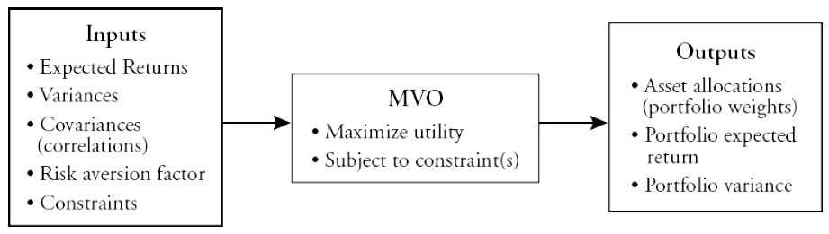

**More recent methods of portfolio optimization or risk aversion**

1. What they are - Capital Asset Pricing Model, PMPT, Indexed funds, Enhanced indexing
2. Advantages compared to MPT
3. Disadvantages compared to MPT ->

Index tracking - Creating a portfolio which aims to give the same return as the market benchmark. Called a *Tracking Portfolio*

Enhanced index tracking - Index tracking except it specifies an excess expected return with regards to the markets benchmark index

Absolute return portfolios = Gives consistent return every period

Market neutral portfolio = Portfolios performance is not correlated with the market index return

Alpha = Expected Return

Beta = Volatility/systematic risk of an asset(s)

Source -> <http://people.brunel.ac.uk/~mastjjb/jeb/plenary.pdf>

**Machine Learning Algorithms**

“Supervised learning”

The optimization and representation approaches look cool and legit, but they have one major drawback: they just exploit information about the past asset movements and co-correlations without any assumptions about their future behavior. Do we agree that in the future assets will move the same as in the past? Not really! That’s why we need some ways to exploit predictions about the future as the allocation weights. -> <https://medium.com/swlh/ai-for-portfolio-management-from-markowitz-to-reinforcement-learning-cffedcbba566>

**Current solutions**

Large investment banks will have developed their own algorithms for portfolio optimization and risk aversion but don’t release to the public ( for obvious reasons)

Find and discuss any publically available portfolio optimization applications or code implementations of these algorithms

**Gaps In Solution**

There have been implementations of programs that allow users to generate portfolios using MPT. However, the idea of allowing the user to select from a range of different investing algorithms has not.

**Objectives**

What it is im building and how it fills in previously mentioned gaps

References

Numba <https://numba.pydata.org/>

Finance and Python: <https://onlinelibrary-wiley-com.ezproxy.rgu.ac.uk/doi/epdf/10.1002/wilm.10489>